Pokhara University

Level: Bachelor | Semester – Spring | Year : 2009
Programme: BE |  | Full Marks: 100
Course: Logic Circuit |  | Pass Marks: 45
 |  | Time : 3hrs.

Candidates are required to give their answers in their own words as far as practicable.
The figures in the margin indicate full marks.

Attempt all the questions.

 | - Explain how Digital and Analog electronic systems are different. Also list out the advantages of digital system.  - Perform the following operation using BCD method.  - 743-234  - 688+355  - Convert the following numbers from the given base to the other bases indicated.  - (11001.11)₂ = ( )₈  - (5FE.DD)₁₆ = ( )₁₀  - (204)₈ = ( )₅  - (777)₈ = ( )₁₆  - (1100) _{GRAY CODE} = ( )₂ | 3×5
 | - Simplify the following expression using Boolean algebra  - 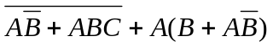  - 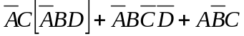  - State and explain De-Morgan's theorem.  - Write down the difference between combinational logic and sequential logic. Also count on the difference between asynchronous and synchronous sequential logic. | 3×5
 | - Use K-map to simplify the given Boolean function in POS and implement the simplified function using 2 input NOR gates only.  F(A,B,C,D)=∑_{m}(2,3,7,10,11,14) , and don’t care condition d(A,B,C,D)= ∑_{m}(1,5,15)  - Design a code converter circuit which converts 84-2-1 code to binary. | 7  8
 | - Differentiate between PLA, PAL and ROM. Implement the following function using ROM.  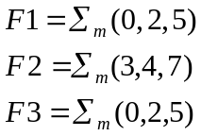  - What do you mean by DE-MUX? Implement the following Boolean function 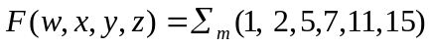using 8 to 1 MUX. | 7  8
 | - Use 'D' flip-flop to design a 3-bit Synchronous UP Counter.  - Explain S-R Flip with its logic diagram, truth table and characteristics equation. | 10  5
 | - Design a 4-bit arithmetic circuits which performs eight different arithmetic operations.  - What do you mean by 'Output Hazard Races'? With the help of diagram explain how Read/Write operation is performed in RAM. | 8  7
 | Write short notes on: (Any Two)  - Status Register  - Parity checker  - Tristate logic | 2×5

